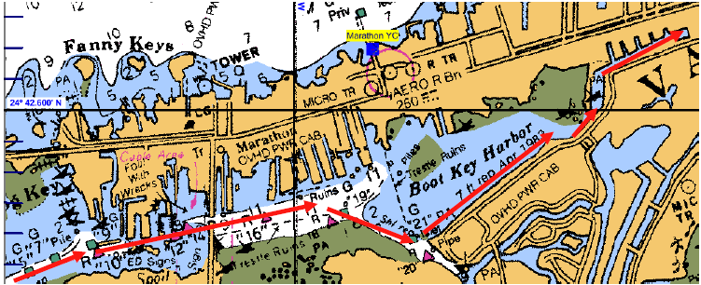
BOOT KEY HARBOR CHRISTMAS BOAT PARADE ROUTE:
Start at West entrance of Boot Key Harbor – 7 mile bridge end – around dusk. Just prior to dusk, around 5:45pm, parade boats are gathered outside of channel markers, or some boats may wait by Lazy Days docks where it’s more protected. They’ll start in around dusk which is about 6:00pm – in no particular order – just fall in behind one another. The USCG boat may or may not be in the lead. Some boats may choose to turn left in channel in front of Lazy Days to “show off”, then turn around and join back in main channel, continuing eastbound toward Dockside Boot Key Harbor where judging occurs. Boats should slow slightly (not stop) and shine a light on their boat number card so that judges know which boat it is. It may take 45 mins or so to reach Dockside. They’ll then proceed slowly down past Sombrero resort. Some will turn around and head back past Dockside again, and others will continue down the canal to the Yacht Haven basin at the end before turning and coming back out. Find a place to moor/dock your boat and meet back at Dockside by around 8:30pm for the awards ceremony and party. Monitor VHF Ch 74 for communications between parade boats.

